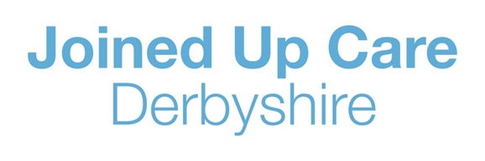
Medicine Order Line
IMPORTANT NOTICE

- The Medicine Order Line (MOL) is currently experiencing increased demand at the moment. We recognise this is causing patient concern and we apologise for any inconvenience

- Once patients get through to a queue position, the waiting times may be longer than usual. We are advising patients that once connected, to hang on the line until through to an operator

- Previously, when our phone lines were busy, patients would hear a variety of differing experiences such as an engaged tone, disconnected tone, no tone. To address this, we have purchased additional phone lines 'SIP TRUNKS'. Although this won't speed up the time patients may wait to speak to an operator, it will allow patients to join the queue and to hear an automated messaged stating our phone lines are busy and to call back later. We appreciate this may still be frustrating to patients but feel the increased awareness of the current status offers some reassurance the service is open

- We are currently suffering from higher-than-normal sickness and recruitment gaps. We are addressing this, and currently in the process of backfilling staffing gaps. 4 new starters have commenced employment within the previous fortnight (since 20th April). A further 8 offers were made last week following a successful recruitment drive and we are currently working through the pre-employment checks for these.

- We have created a communication package for all stakeholders to raise awareness of the current state within the MOL and what other routes can be taken such as patients utilising the NHS App and the MOL call back service

- With the upcoming Jubilee bank holiday, the MOL is accepting prescription requests up to 14 days early rather than the usual 7 days early. This means prescriptions due over the bank holiday can be ordered from the 19th of May

- To offer increased support during the bank holiday week (w/c 30th May) we have made the exception to extend our opening hours. We have asked staff to volunteer to work to extend our opening times until 5pm Monday 30th May – Wednesday 1st June and 8am-12pm on the bank holiday of Thursday 2nd June. Please note, most GP practices will remain closed on the bank holidays

- If any patients have access to email, they can order prescriptions by emailing the MOL with their name, date of birth, GP surgery and telephone number – one of the MOL operators will call them back within 48 hours to process the prescription request
  - ddccg.northmolonlinerequests@nhs.net for those who would normally call the 01246 number
  - ddccg.southmolonlinerequests@nhs.net for those who would normally call the 0115 number

- If any patients have access to the internet / apps, could we please suggest they try these alternative ordering methods (online ordering via the practice / NHS app). This will free up the busy phone lines for patients who have no other means of ordering their repeat prescriptions

- The MOL team are continuing to work hard to mitigate the temporary service issues with new ideas and solutions

