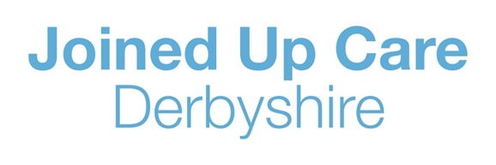
How to order your Repeat prescription

- NHS App:

If you have a smartphone or tablet device, you can download the NHS App where you will be able to request a new repeat prescription and choose a pharmacy for your prescriptions to be sent to.
Further details about the NHS App and what additional services are available can be found here: www.nhs.uk/using-the-nhs/nhs-services/the-nhs-app/

- Electronic Repeat dispensing (eRD) also known as batch prescriptions:

If you use the same medicines regularly, you may be able to benefit from electronic Repeat Dispensing (eRD). Your repeat prescriptions will be sent to your nominated pharmacy in one go. This means you won’t have to re-order or collect repeat prescriptions from your GP practice every time you need more medicine.
Talk to your GP or the person who prescribes your medicines to ask if you can use electronic Repeat Dispensing.

- GP practice online ordering services:

If you have access to the internet, you could manage your prescriptions online with your GP practice. This option can be discussed with a member of the GP practice reception team, who will be able to assist.

- The Medicine Order Line (MOL):

For GP practices that have access to the MOL, it is a convenient way to order your prescriptions. This is via a dedicated telephone line where you will speak to an experienced Medicine Order Line Operative.
For GP practices in North Derbyshire that are on board with the MOL please phone 01246 588860.
For GP practices in South Derbyshire that are on board with the MOL please phone 0115 855 0260.
More information and a list of GP practices currently on board with the MOL can be found at: https://www.derbyandderbyshireccg.nhs.uk/your-health-services/information-for-patients/prescription-medicines-order-line-mol/

- MOL email call back system:

To save you time, if you have access to email, you can send a request for a health professional to call you back to take your prescription request within 48 hours (excluding weekends and Bank Holidays).
In your email, please include your full name, date of birth, contact telephone number and your GP practice name.
For GP practices in North Derbyshire that are on board with the MOL please email - ddccg.northmolonlinerequests@nhs.net
For GP practices in South Derbyshire that are on board with the please email - ddccg.southmolonlinerequests@nhs.net
More information and a list of GP practices currently on board with the MOL can be found at: www.derbyandderbyshireccg.nhs.uk/your-health-services/information-for-patients/prescription-medicines-order-line-mol/

- Alternative arrangements:

If your GP practice agrees that ordering a repeat prescription via the above options is not suitable, they may be able to make alternative arrangements for prescriptions to be ordered with them directly. Some GP practices may be able to receive paper medication requests or medication requests over the telephone.

